SPECIFICATIONS
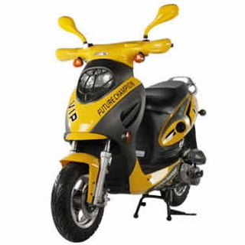
SL50QT-2 50
Dimensions
Overall Length: 71
Overall Width: 28
Overall Height: 41
Wheelbase: 51
Engine
Engine Type: 4 Stroke Single Air-Forced Cool
Displacement: 50cc
Starting System: Electric/Kick
Fuel
Tank Capacity: 4.5L
Tire
Size,Front: 3.50-10-4PR
Size,Rear: 3.50-10-4PR
Braking
Front: Disk
Rear: Drum
Electrical
Battery Type: 12V, 7AH

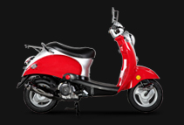

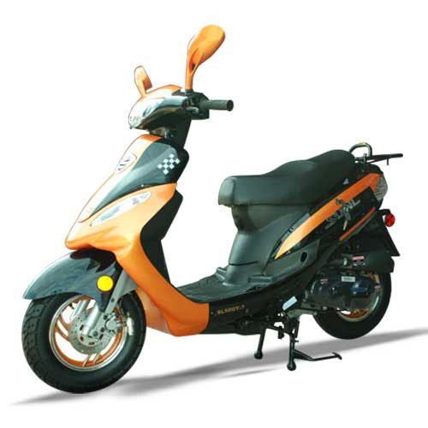
SL50QT-7
Dimensions
Overall Length: 65.3
Overall Width: 26.7
Overall Height: 42.1
Wheelbase: 47.04
Engine
Engine Type: Air-Cool, 4-Stroke
Displacement: 50cc
Starting System: Electric/Kick
Fuel
Tank Capacity: 4.40
Tire
Size,Front: 3.50-10
Size,Rear: 3.50-10
Braking
Front: Disk
Rear: Drum
Electrical
Battery Type: 12V/4AH
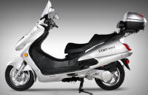
SL150-6
Dimensions
Overall Length: 81.49
Overall Width: 29.52
Overall Height: 55.51
Wheelbase: 57.08
Engine
Engine Type: 4 Stroke, Single Cylinder, Air-Forced Cool
Displacement: 150cc
Starting System: Electric/Kick
Fuel
Tank Capacity: 12L
Tire
Size,Front: 120/70-12
Size,Rear: 4.00-12
Braking
Front: Disk
Rear: Disk
Electrical
Battery Type: 12V/7AH

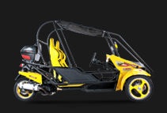
SL150T-27
Dimensions
Overall Length: 108.26
Overall Width: 68.11
Overall Height: 60.23
Engine
Starting System: Electric Start
Tire
Size,Front: 130/60-13
Size,Rear: 130/60-13
Braking
Front: Disc
Rear: Disc
Electrical
Ignition System: CDI

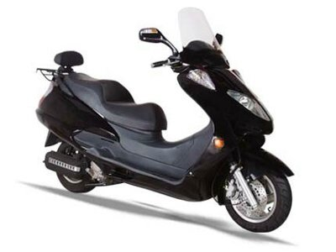
SL250-2
Dimensions
Overall Length: 85.43
Overall Width: 28.93
Overall Height: 55.51
Wheelbase: 57.08
Engine
Engine Type: 4 Stroke, Water- Cooled
Displacement: 250cc
Starting System: Electric
Fuel
Tank Capacity: 10
Tire
Size,Front: 120/70-12
Size,Rear: 130/60-13
Braking
Front: Disc
Rear: Disc
Electrical
Battery Type: 12V, 9AH
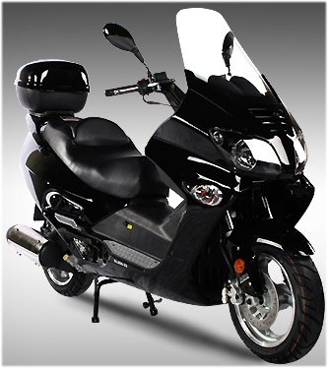
SL250-22
Dimensions
Overall Length: 88.18
Overall Width: 28.34
Overall Height: 55.7
Wheelbase: 63.97
Engine
Engine Type: 4 Stroke, Water-Cooled
Displacement: 250cc
Starting System: Electric
Fuel
Tank Capacity: 10
Tire
Size,Front: 130/60-13
Size,Rear: 130/60-13
Braking
Front: Disc
Rear: Disc
Electrical
Battery Type: 12V, 9AH

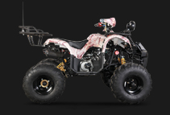
ATV-138
Dimensions
Overall Length: 60.6
Overall Width: 38.5
Overall Height: 39.3
Wheelbase: 39.3
Engine
Engine Type: 152FMH
Displacement: 107cc
Bore x Stroke: 2.0x1.9
Starting System: Electric
Fuel
Tank Capacity: 3.4
Tire
Size,Front: 19x7-8
Size,Rear: 18;A9.5;8
Braking
Front: Drum brake
Rear: Disc brake
Electrical
Ignition System: CDI
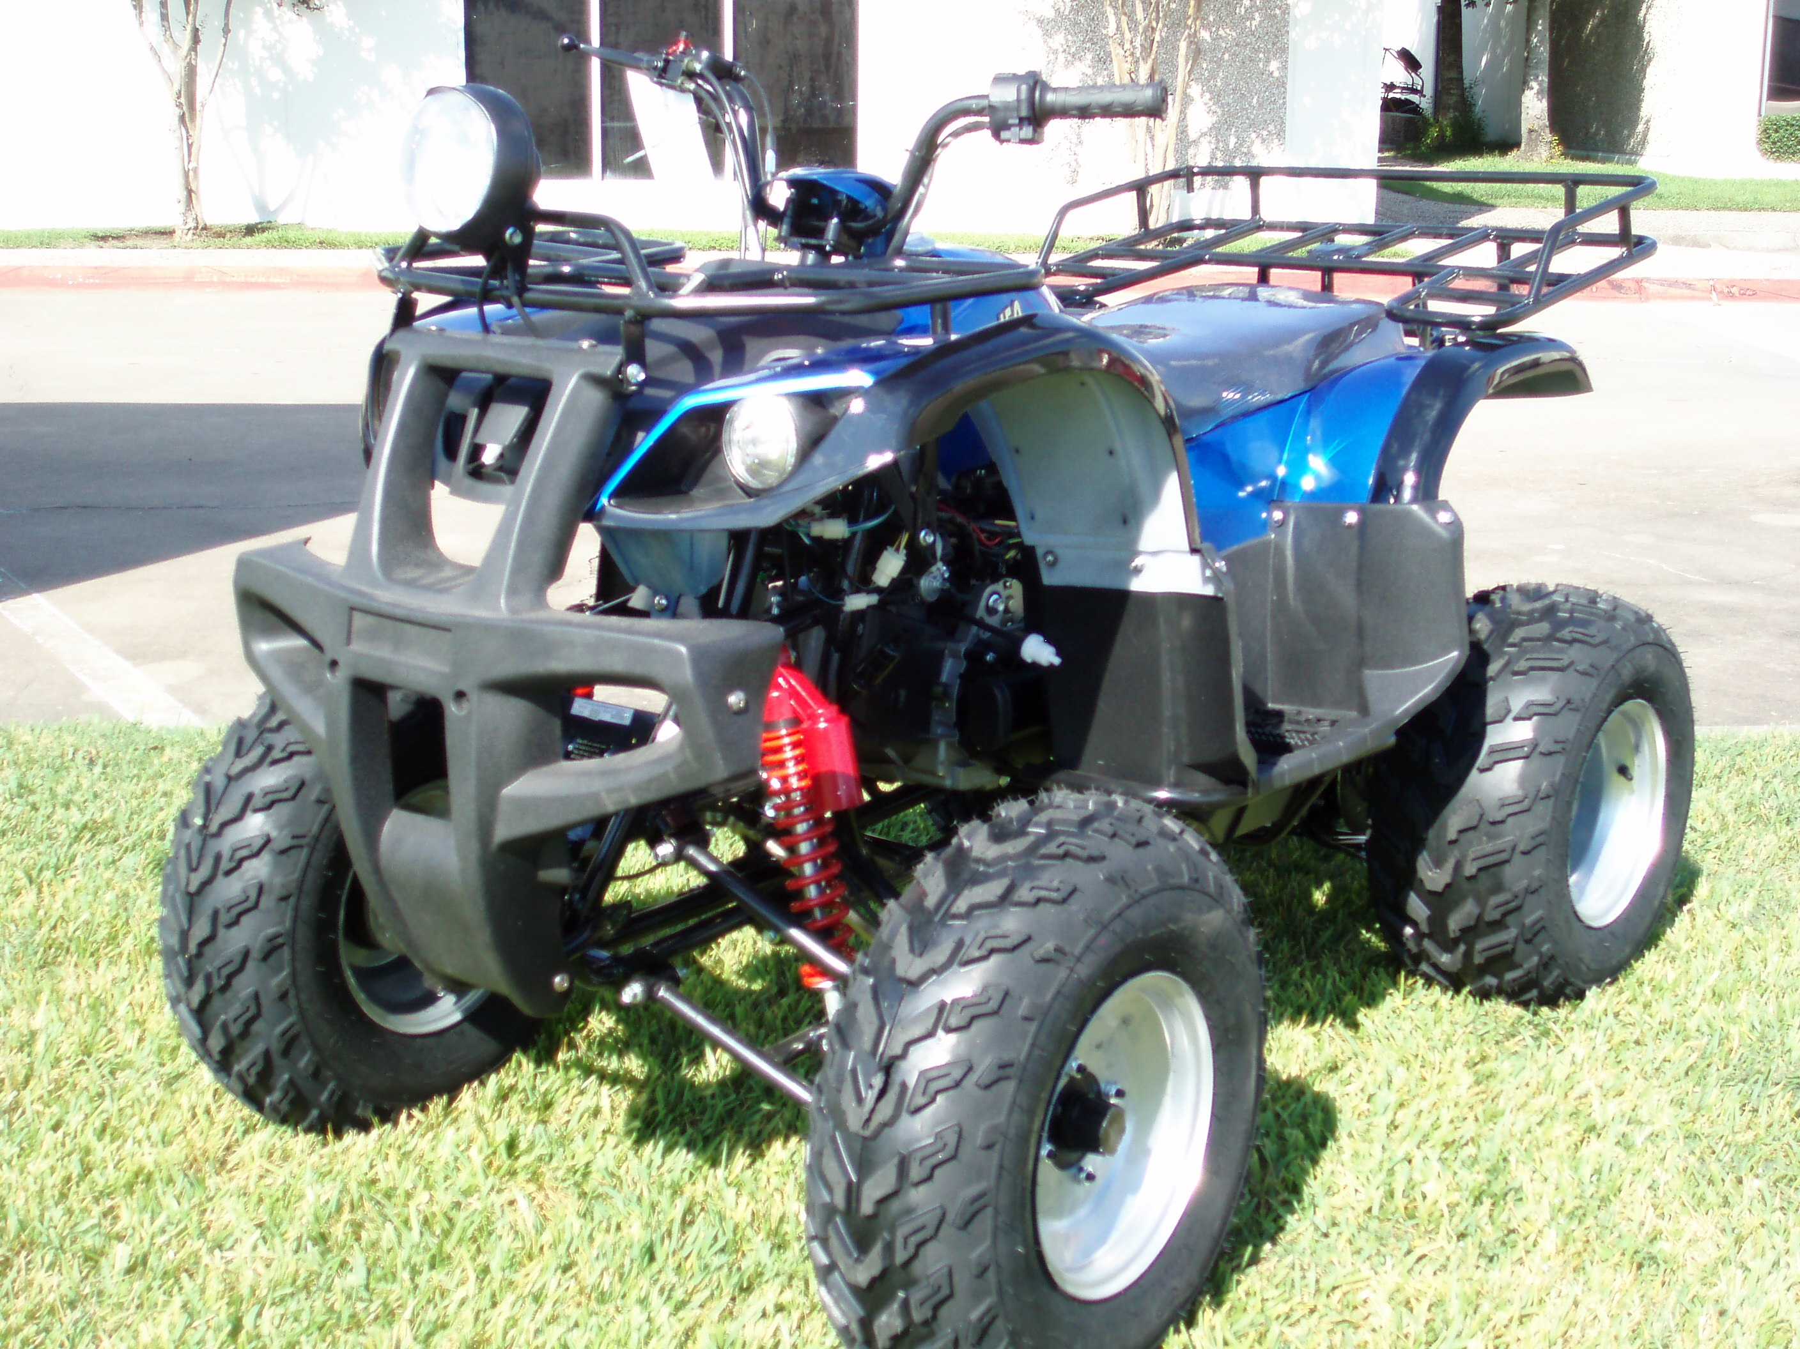
ATV-175
Dimensions
Overall Length: 69
Overall Width: 43
Overall Height: 46
Engine
Engine Type: Single Cylinder, 4 Stroke, Air Cooled
Displacement: 150cc
Starting System: Electric start
Tire
Size,Front: 23x7x10
Size,Rear: 23x10x10
Braking
Front: Disc brake
Rear: Disc brake
Electrical
Ignition System: CDI
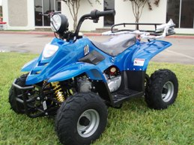
ATV-110L
Dimensions
Overall Length: 45.6
Overall Width: 26.7
Overall Height: 24
Engine
Engine Type: 1-Cylinder, 4-Stroke, Air Cooled
Displacement: 110cc
Starting System: Electric
Tire
Size,Front: 145/70-6
Size,Rear: 145/170-6
Braking
Front: Disk brake
Rear: Disk brake
Electrical
Ignition System: CDI
Battery Type: 12v, 65AH

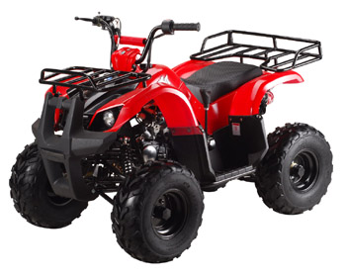
ATV-125D
Dimensions
Overall Length: 60.6
Overall Width: 38.5
Overall Height: 39.3
Wheelbase: 39.3
Engine
Engine Type: 152FMH
Displacement: 107cc
Bore x Stroke: 2.0x1.9
Starting System: Electric
Fuel
Tank Capacity: 3.4
Tire
Size,Front: 19x7-8
Size,Rear: 18;A9.5;8
Braking
Front: Drum brake
Rear: Disc brake
Electrical
Ignition System: CDI
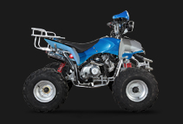
ATV-135
Dimensions
Overall Length: 57.8
Overall Width: 36.2
Overall Height: 37.4
Wheelbase: 33.8
Engine
Engine Type: 107cc
Displacement: 152FMF
Bore x Stroke: 2.0x1.9
Starting System: Electric
Fuel
Tank Capacity: 3.4
Tire
Size,Front: 160/80-7
Size,Rear: 160/80-7
Braking
Front: Drum brake
Rear: Disc brake
Electrical
Ignition System: CDI

